SONALI

RESUME

Contact No : +91 – 9741696878
Email Id : sonugouda187@gmail.com

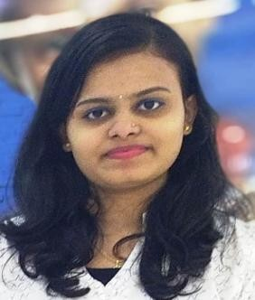Career objective

To secure a challenging position in a reputable organization to expand my learning, knowledge and skills.

Educational Qualification

 SSLC from St Theresa English medium high school, Belthangady, D.K District.
 PUC from Govt pu College Koyyuru, Belthangy DK District.
 Diploma from KPT, Mangalore, DK District.

Work Experience

Worked as a branch relationship executive in SBI Credit card department with 8 months experience.
Worked as an CCO (Customer care officer) in Team G Solutions PVT LTD Tata Play with 1 year experience.
worked AS A TELECALLER BACKEND DEPARTMENT IN WORK RAPIDO MANAGEMENT LLP with 6 months Experience

Personel Strengths

 Project management .
 Strong decision maker.
 Complex problem solver.
 Creative design.
 Innovative.
 Service focused.

Technical Skills
 Customer Service
 MS Office
 Product Knowledge
 Excel data entry.

Languages Known

 English
 Hindi
 Kannada
 Tulu

Personal profile

Name : SONALI
Father Name : JATHANNA GOWDA
Date Of Birth : 13/APRIL/1999
Gender : Female
Nationality : Indian
Religion : Hindu Marital Status : Un-Married
Address : 23rd main road Mernahalli JP Nagar 2nd phase Bangalore-560078

Declaration

I hereby confirm that the information given above is true & useful to the best of my knowledge.

Date :
Place:

Yours sincerely,
SONALI

